**Report on**

**Workshop on Pedagogical Action Research**

**June 18, 2019**

**Teaching Learning Centre**

**Tezpur University**

A one-day Workshop on Pedagogical Action Research was organized by Teaching Learning Centre, Tezpur University on June 18, 2019. The workshop aimed to give an overall idea and guidelines of pedagogical research for teachers and aspirants. There were 35 participants including Faculty members and Research Scholars from various academic institutions. For the day long program two resource persons were invited, they were Emeritus Fellow Prof. Swarnalata Das (Retired Professor), Dept. of Education, Gauhati University and Prof. Padmini Bhuyan Baruah, Head, Dept. of ELT, Gauhati University. Both the resource persons took all the sessions jointly. In the first session a brief introduction to action research was given where a theoretical aspects of action research was discussed with the participants. It was followed by another session where the resource person discussed in detail on components of research, differences of traditional and action research, orientation and goal direction of action research, different stages of action research along with planning for the research. Post lunch session was activity session where participants worked out in groups about identifying action research problems, reasons for writing an action research report along with checklist while doing action research. The program ended successfully with a brief valedictory session. In the session invited guests deliberated on this very important aspect of research followed by feedback from participants and the program ended with speech from Prof. Mrinmoy K. Sarma, Director, Teaching Learning Centre, Tezpur University.

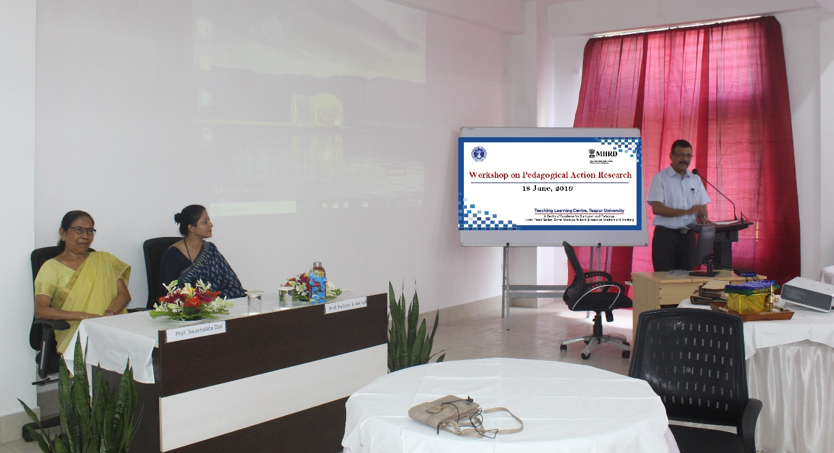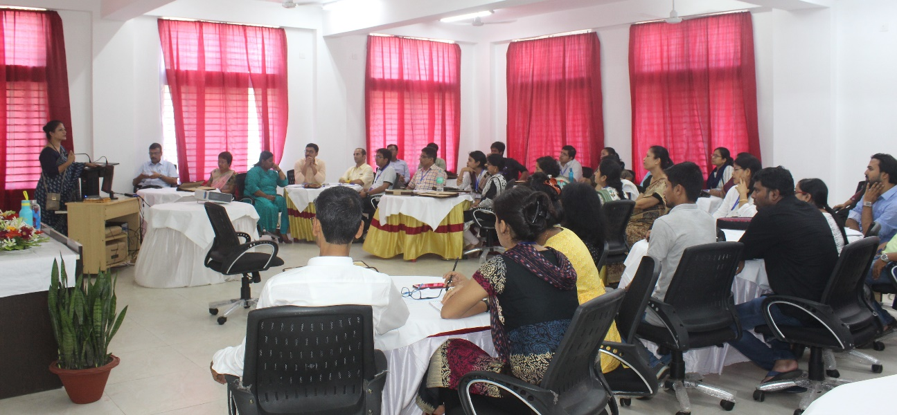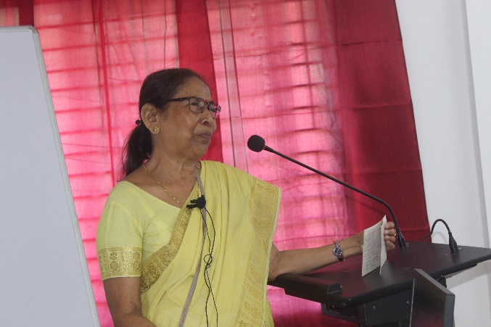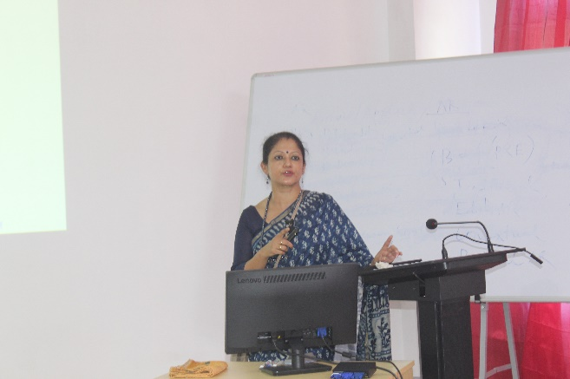Some moments from the workshop:

Prof. Padmini Bhuyan Baruah

Prof. Swarnalata Das



